Case Study
Problem Scenario: The Indian Government wants to develop a Library Management System (LMS) to store information of the members, books, status of books issue, book availability and suppliers details
List of Tables:
Table #1: LMS_MEMBERS
Table #2: LMS_SUPPLIERS_DETAILS
Table #3: LMS_FINE_DETAILS
Table #4: LMS_BOOK_DETAILS
Table #5: LMS_BOOK_ISSUE
ER Diagram:
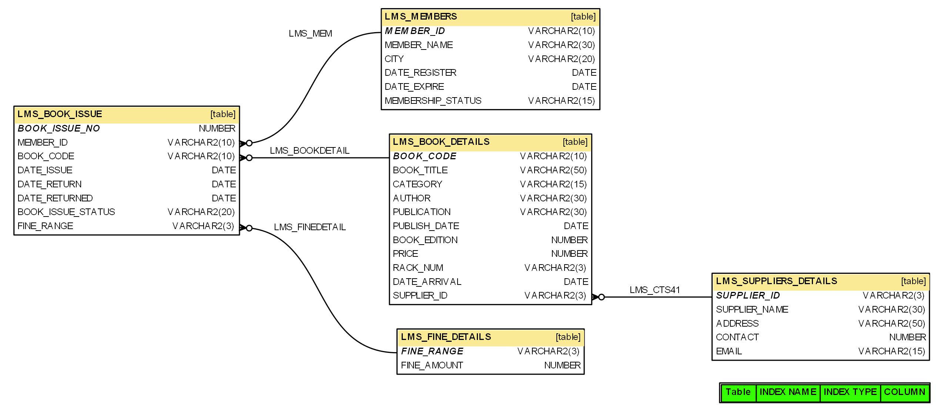
Database and Table Creations - DDL Queries:

Loading Data - DML Queries:

Simple Questions:
Problem # 1:
Write a query to display the member id, member name, city and membership status who are all having life time membership. Hint: Life time membership status is “Permanent”.

Problem # 2:
Write a query to display the book code, publication, price and supplier name of the book witch is taken frequently.

Problem # 3:
Write a query to display the member id, member name who have taken the book with book code 'BL000002'.

Problem # 4:
Write a query to display the book code, book title and author of the books whose author name begins with 'P'.

Problem # 5:
Write a query to display the total number of Java books available in library with alias name ‘NO_OF_BOOKS’.

Problem # 6:
Write a query to list the category and number of books in each category with alias name ‘NO_OF_BOOKS’.

Problem # 7:
Write a query to display the number of books published by "Prentice Hall” with the alias name “NO_OF_BOOKS”.

Problem # 8:
Write a query to display the book code, book title of the books which are issued on the date "1st April 2012".

Problem # 9:
Write a query to display the member id, member name, date of registration and expiry date of the members whose membership expiry date is before APR 2013.

Problem # 10:
write a query to display the member id, member name, date of registration, membership status of the members who registered before "March 2012" and membership status is "Temporary"

Problem #11:
Write a query to display the member id, member name who’s City is CHENNAI or DELHI. Hint: Display the member name in title case with alias name 'Name'.

Problem #12:
Write a query to concatenate book title, author and display in the following format.
Book_Title_is_written_by_Author
Example: Let Us C_is_written_by_Yashavant Kanetkar
Hint: display unique books. Use “BOOK_WRITTEN_BY” as alias name.

Problem #13:
Write a query to display the average price of books which is belonging to ‘JAVA’ category with alias name “AVERAGEPRICE”.

Problem #14:
Write a query to display the supplier id, supplier name and email of the suppliers who are all having gmail account.

Problem#15:
Write a query to display the supplier id, supplier name and contact details. Contact details can be either phone number or email or address with alias name “CONTACTDETAILS”. If phone number is null then display email, even if email also null then display the address of the supplier. Hint: Use Coalesce function.

Problem#16:
Write a query to display the supplier id, supplier name and contact. If phone number is null then display ‘No’ else display ‘Yes’ with alias name “PHONENUMAVAILABLE”. Hint: Use ISNULL.

Problem#17:
Write a query to display the member id, member name, city and member status of members with the total fine paid by them with alias name “Fine”.

Average Questions:
Problem # 1:
Write a query to display the member id, member name of the members, book code and book title of the books taken by them.
Problem # 2:
Write a query to display the total number of books available in the library with alias name “NO_OF_BOOKS_AVAILABLE” (Which is not issued). Hint: The issued books details are available in the LMS_BOOK_ISSUE table.

Problem # 3:
Write a query to display the member id, member name, fine range and fine amount of the members whose fine amount is less than 100.

Problem # 4:
Write a query to display the book code, book title, publisher, edition, price and year of publication and sort based on year of publication, publisher and edition.

Problem # 5:
Write a query to display the book code, book title and rack number of the books which are placed in rack 'A1' and sort by book title in ascending order.

Problem # 6:
Write a query to display the member id, member name, due date and date returned of the members who has returned the books after the due date. Hint: Date_return is due date and Date_returned is actual book return date.

Problem # 7:
Write a query to display the member id, member name and date of registration who have not taken any book.

Problem # 8:
Write a Query to display the member id and member name of the members who has not paid any fine in the year 2012.

Problem # 9:
Write a query to display the date on which the maximum numbers of books were issued and the number of books issued with alias name “NOOFBOOKS”.

Problem # 10:
Write a query to list the book title and supplier id for the books authored by “Herbert Schildt" and the book edition is 5 and supplied by supplier ‘S01’.

Problem # 11:
Write a query to display the rack number and the number of books in each rack with alias name “NOOFBOOKS” and sort by rack number in ascending order.

Problem # 12:
Write a query to display book issue number, member name, date or registration, date of expiry, book title, category author, price, date of issue, date of return, actual returned date, issue status, fine amount.

Problem # 13:
Write a query to display the book code, title, publish date of the books which is been published in the month of December.

Problem # 14:
Write a query to display the book code, book title ,supplier name and price of the book witch takes maximum price based on each supplier.

Problem # 15:

Write a query to display book code, book name, and publisher, how old the book is. Sorted as older to newer.

Complex Questions:
Problem # 1:
Write a query to display the book code, book title and supplier name of the supplier who has supplied maximum number of books. For example, if “ABC Store” supplied 3 books, “LM Store” has supplied 2 books and “XYZ Store” has supplied 1 book. So “ABC Store” has supplied maximum number of books, hence display the details as mentioned below.
Example:
BOOK_CODE BOOK_TITLE SUPPLIER_NAME
BL000008 Easy Reference for Java ABC STORE
BL000001 Easy Reference for C ABC STORE
BL000003 Easy Reference for VB ABC STORE

Problem # 2:
Write a query to display the member id, member name and number of remaining books he/she can take with “REMAININGBOOKS” as alias name. Hint: Assuming a member can take maximum 3 books. For example, Ramesh has already taken 2 books; he can take only one book now. Hence display the remaining books as 1 in below format.
Example:
MEMBER_ID MEMBER_NAME REMAININGBOOKS
LM001 RAMESH 1
LM002 MOHAN 3

Problem # 3
Write a query to display the supplier id and supplier name of the supplier who has supplied minimum number of books. For example, if “ABC Store” supplied 3 books, “LM Store” has supplied 2 books and “XYZ Store” has supplied 1 book. So “XYZ Store” has supplied minimum number of books, hence display the details as mentioned below.
Example:
SUPPLIER_ID SUPPLIER_NAME
S04 XYZ STORE

